How to use the Datascape?

The Toflit18 Datascape is a useful tool for exploring the collected data on the French foreign trade during the 18th century. It has several features and the aim of that documentation is to show you all the utilities of that instrument.

The user interface of the home page

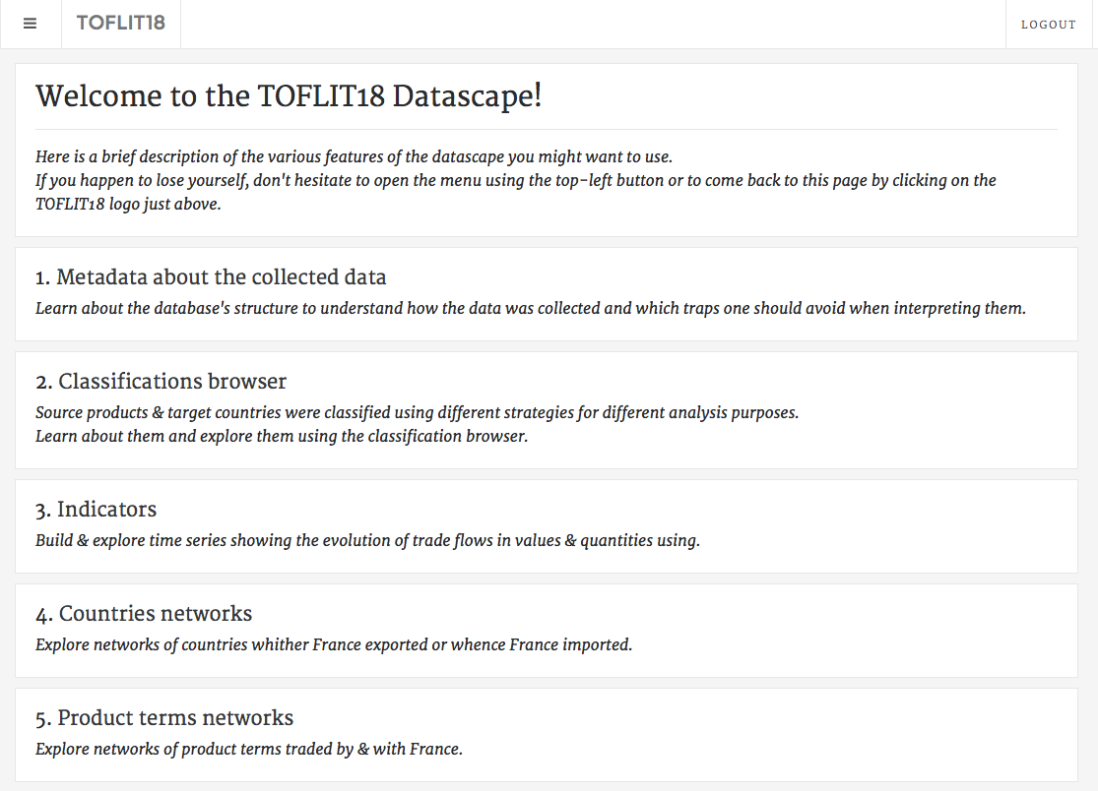

The home page describes the different features of the Datascape you can use. You can come back to the home page at any time by clicking on the toflit18 logo (surrounded in red). All these features will be described below.

1. Metadata about the collected data

By clicking on “Metadata about the collected data”, you can learn some information about the database’s structure in order to understand how the data was collected. Moreover, you can see by this feature which data was collected and which one was not.

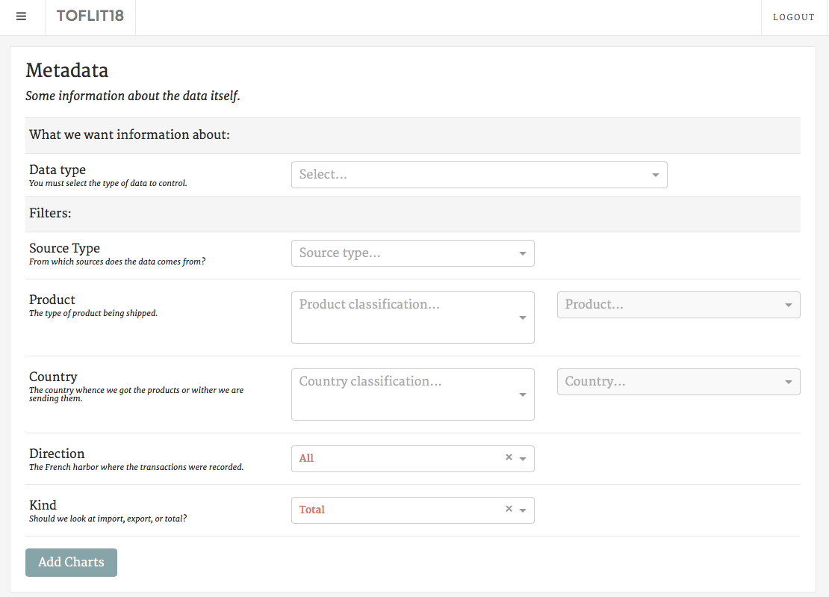

Firstly, you need to select the type of data you want information on (“Data type”). There are several types:

* “Direction”: it shows all the chambers of commerce from which provide the data, you can see where the data was available and which places in France traded the most.
* “Source type”: it shows all the types of sources, if it was national sources, local sources, sources from the former colonies, etc..
* Different classifications under merchandises: “Sources”, “Orthographic Normalization” and “Simplification” concern the spelling of merchandises (how it is written in the sources, how there are normalized and simplified); “Medicinal products”, “Hamburg classification”, “North America”, “Eden Treaty”, “Grains”, “SITC”, “SITC EN” and “SITC FR” are several merchandises classifications.  
  These types of data show the occurrences (number of flows) of each category of the classification selected for every year.
* Different classifications under countries: “Sources”, “Orthographic Normalization” and “Simplification” concern the spelling of countries (how it is written in the sources, how there are normalized and simplified); “Grouping” and “O’Brien” are countries classifications.

These types of data show the number of flow of each country or category of the classification selected for every year.

Thus, you can use filters to choose a source type, a category of products (or just a single product), a group of countries (or just a single country), a direction and you can separate exports from imports.

After your choices made, you have to click on the “Add Charts” button to see the relevant information.

1. Classifications browser

By clicking on “Classifications browser”, you can find all the classifications for products and countries and all the items included in each category of classification.

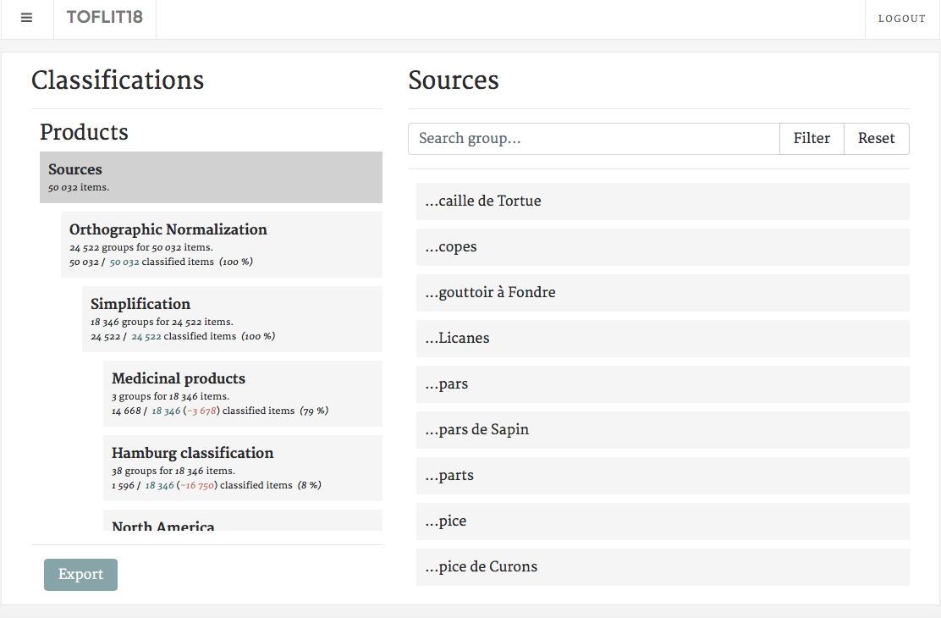

As an example, if you search in which SITC (Standard International Trade Classification) category is an item, click to SITC into the scroll-down menu on the left and write its name into the area “Search item”. Then, press Enter or click on Filter and the datascape show you its classification.

E.G.: “Tabac en feuilles” is classified into the category n°1 in the SITC classification.

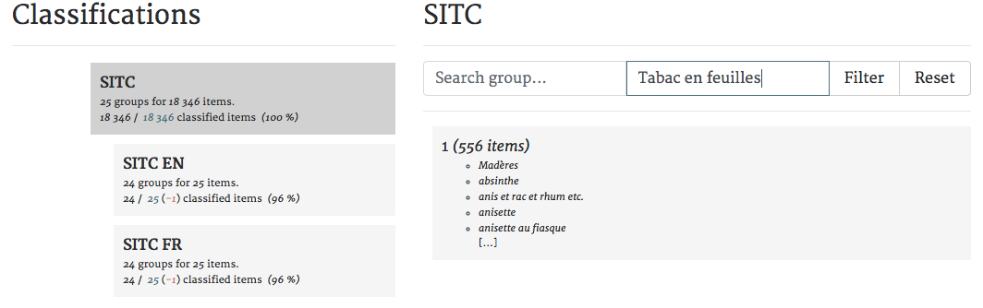

And if you do not know what is the category n°1 in the classification SITC, you can select SITC EN and it will show you all the categories with their significations.

You can also do the same thing with countries. Sometimes, in the sources, the place indicated is not a country but it can be a city of one country. For example, we can find “Venise” and it is regrouped into the category “Italie” in the classification Grouping.

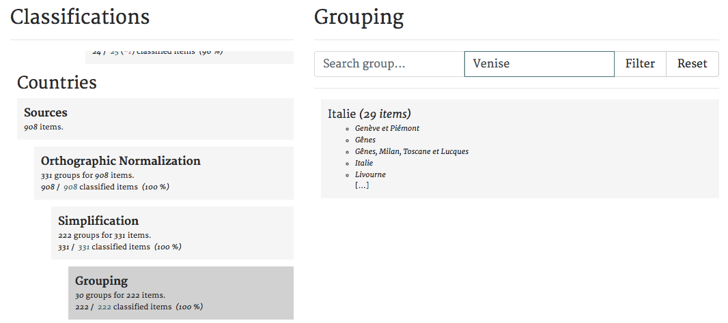

1. Indicators

By clicking on “Indicators”, you can explore the database and discover time series showing the evolution of trade flows. You can see the number of flows and its value per year, choosing one direction or all, and the number of elements per year by direction.

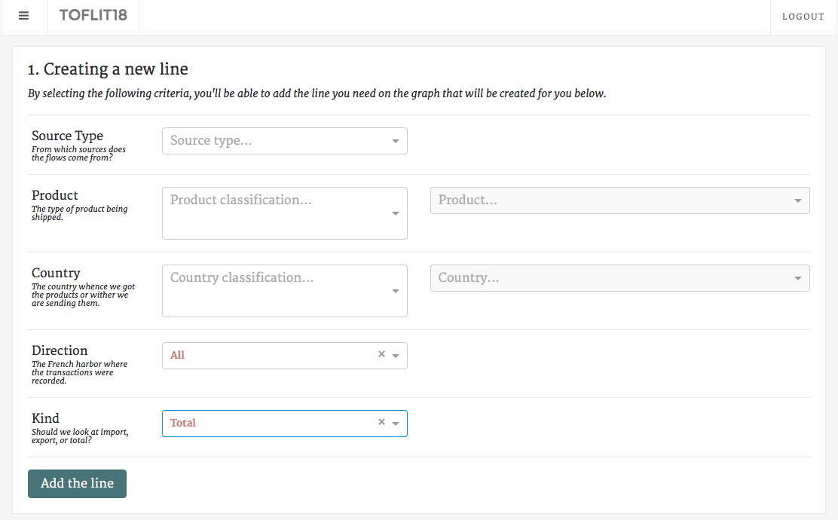

As in the category “Metadata about the collected data”, you can choose which source type you want to keep and which product you would like information. You can also choose a country with which France has traded, a direction and a kind (Exports or Imports). After that, you have to click on “Add the line”, and you can now explore your results.

Of course, you can fill in none of the criteria, click in “Add the line” and have results about the entire database. That is what we have done in the following example: you can see the number of flows per year and its value from all the sources, and the number of directions per year found in the database.

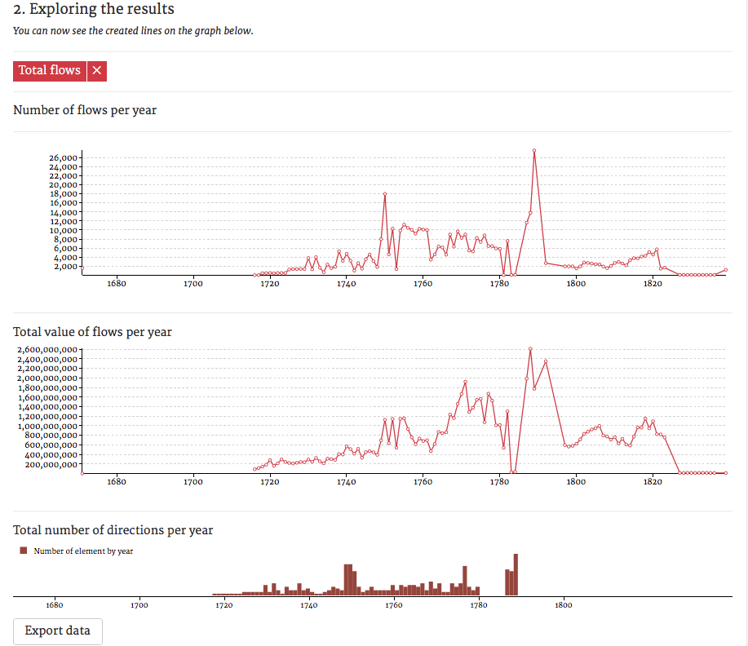

Moreover, you can compare two or more time series. For instance, you can compare the evolution of the imports with the one of the exports, you just have to select Imports in the criteria « Kind » and « Add the line »; thereafter, you have to do the same thing with Exports, and the two lines will be represented on each graphs.

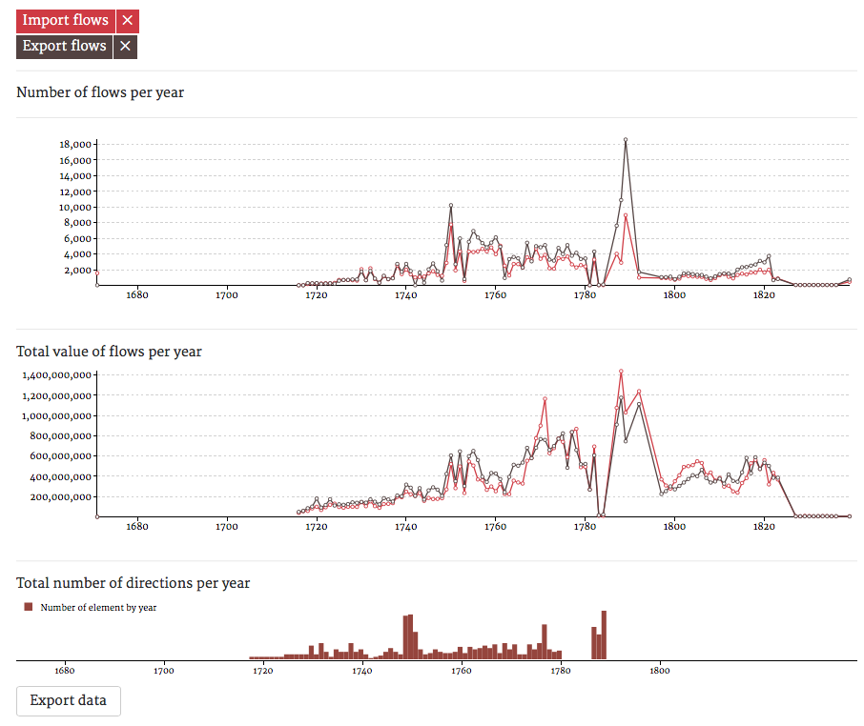

If you want, you can also export your results in text using the button “Export data” at the bottom of the page.

1. Countries network

By clicking on “Countries network”, you can explore relationship between directions and countries, that is to say between places of trade in France and their partners.

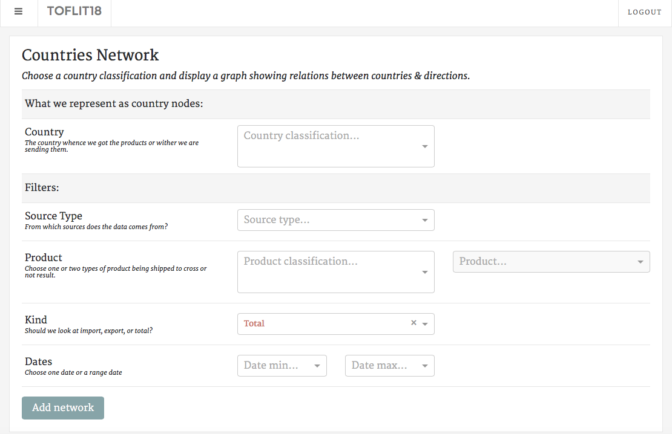

First, you are compelled to choose which classification of countries you want to represent nodes.

After that, you can choose filters (or not, it is not required to add a network): source type, product, kind (Imports or Exports) and dates.

Thereafter, you click on “Add network”, and the graph representing this network will appear. As an example, we have chosen “simplification” as country nodes and no filter.

That is what appears on your screen:

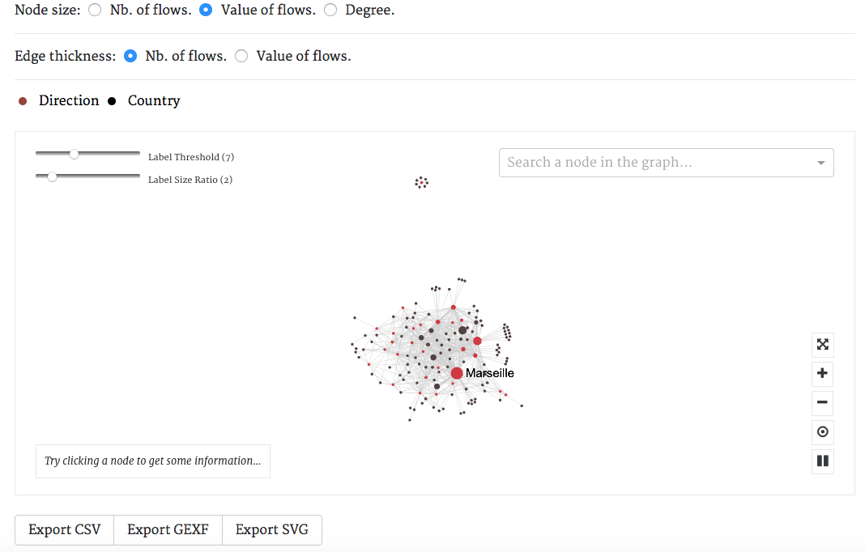

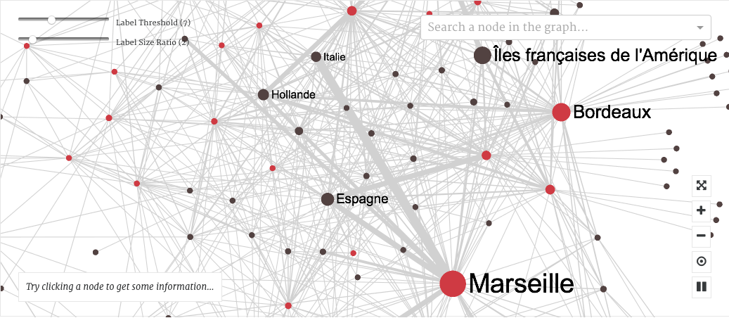

You can see a real network and you can “play” with it. Zoom if you want to have a better visibility of relationships between directions and countries.

In that interface, you have different possibilities with different buttons:



Put the network representation in full screen

Zoom in or zoom out

Restart the initial representation

Break the representation

Moreover, you can choose if you want that the nodes represent the number of flows between directions and countries, or the value of flows. Thus, bigger is the node, higher is the number of flows (or the value of flows).

You can do the same thing with the links between nodes (choose between number or value of flows).

Furthermore, you can also see more labels of countries and directions by diminishing the label threshold and increase the size of these labels by raising the label size ratio.

Finally, you can search a node in the representation with the tool “Search a node in the graph” and getting some information on the country or direction chosen by clicking on a node (you will have the number of flows, the value of these flows and the degree).

And if you want to export your results, you can exports the data in CSV, GEFX or SVG.

1. Product terms network

By clicking on “Product terms network”, you can explore relationship between product terms traded by and with France. It allows you to see how products terms can be related (as an example, the products “feuilles de tabac” and “feuilles de fer” are linked by the term “feuilles”).

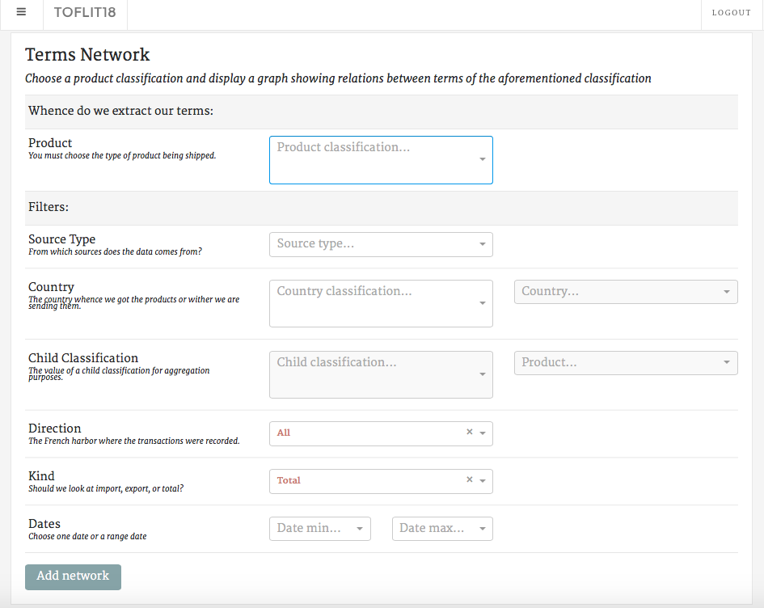

First, you are compelled to choose which classification of products you want to represent nodes.

After that, you can choose filters (or not, it is not required to add a network): source type, country, direction, kind (Imports or Exports) and dates.

Thereafter, you click on “Add network”, and the graph representing this network will appear. As an example, we have chosen “simplification” as products nodes and no filter.

That is what appears on your screen:

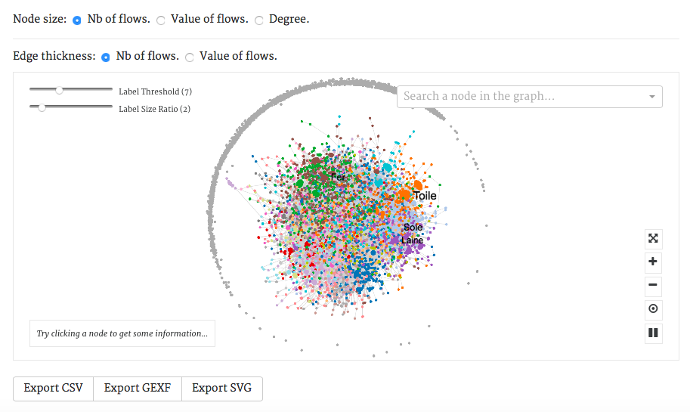

You can do all the options that are detailed in “Countries network”, but it concerns here products and not countries and directions.

If you click on a node, you will see the number of flows of that product term, its total value and the degree of that term.